**Security Settings at Different Levels**

**Object Accessibility**

Traverse to the profile for whom the object permissions are to be set through Administration Setup -> Manage Users -> Profiles, and click Edit.

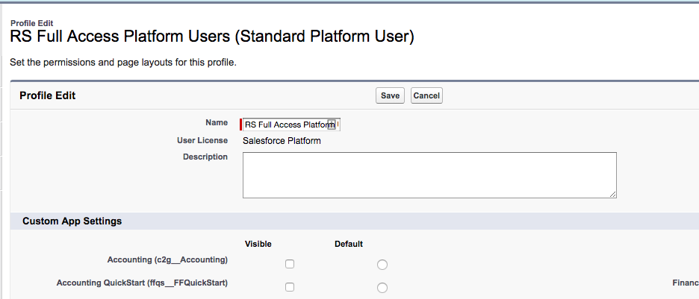

Under the custom objects section, search for the objects and accordingly assign Read, Write, Edit, Delete, View All and Modify All permissions.

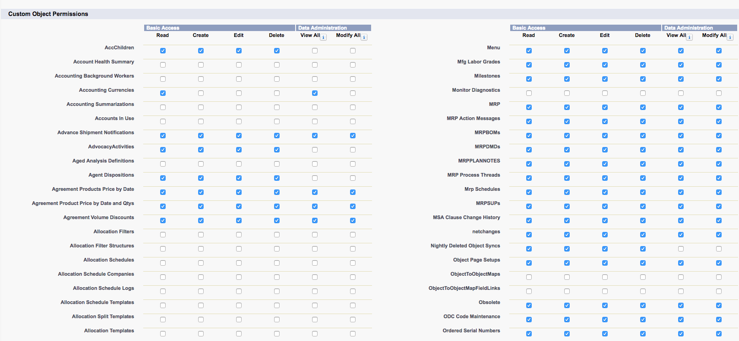

**Field Accessibility**

**Setup -> Administration Setup -> Security Controls -> Field Accessibility.**

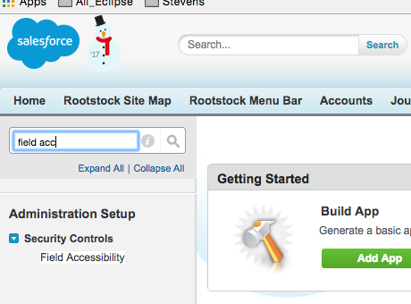

**Search for the field by the field name, and click on it.**

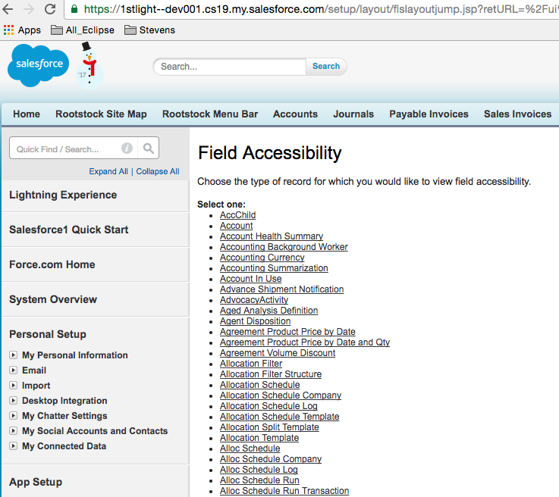

**We can set the permissions by 2 ways, ‘View by Profile’ and ‘View by Fields’.**

**a. View by Profile: As shown below, from the drop down select the profile for which you want to set the field permissions, in front of the desired field there is ‘Editable’ OR ‘Hidden’ click on it.**

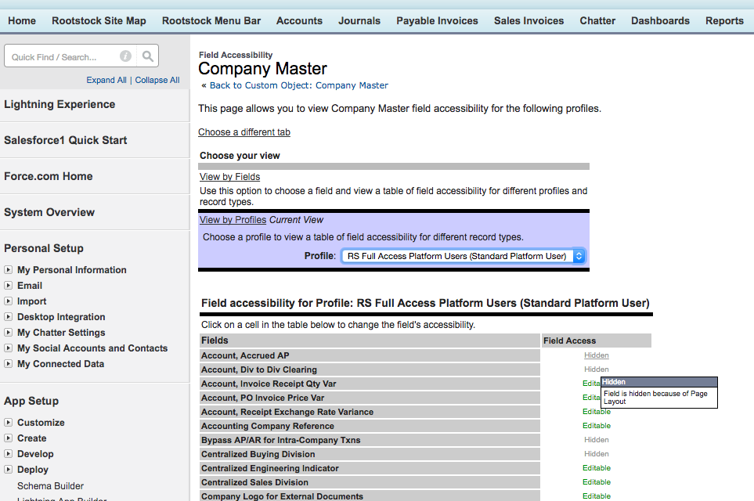

**Once clicked, you need to check the BOTH ‘Visible’ checkboxes under Field-Level Security and Page Layout section, this makes the ‘hidden’ field to ‘editable’.**

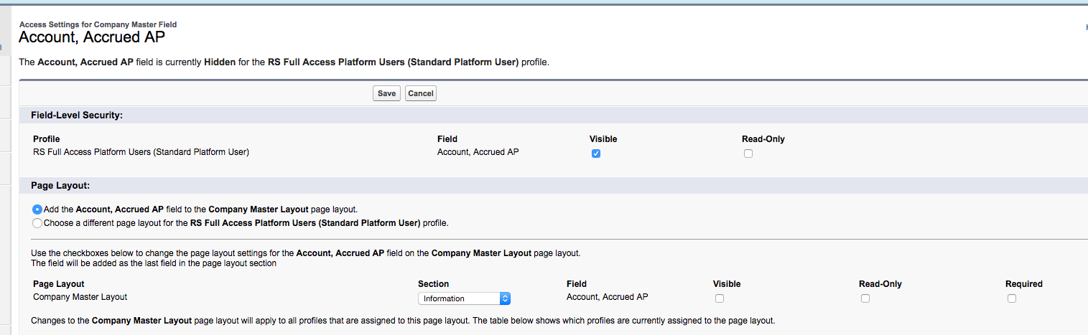

**b. View by Fields: Select the field from the drop down and then click on the ‘Editable’ or ‘ Hidden’ in front of the desired profile**

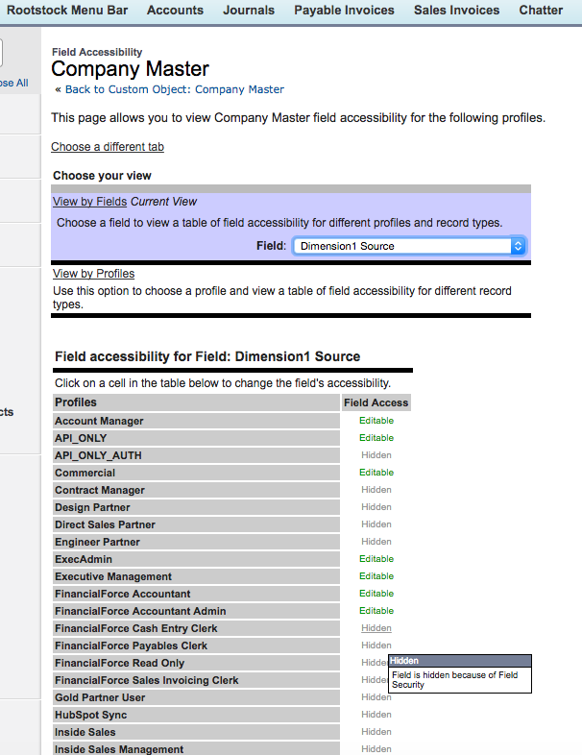

**Select both the ‘Visible’ checkboxes and save.**

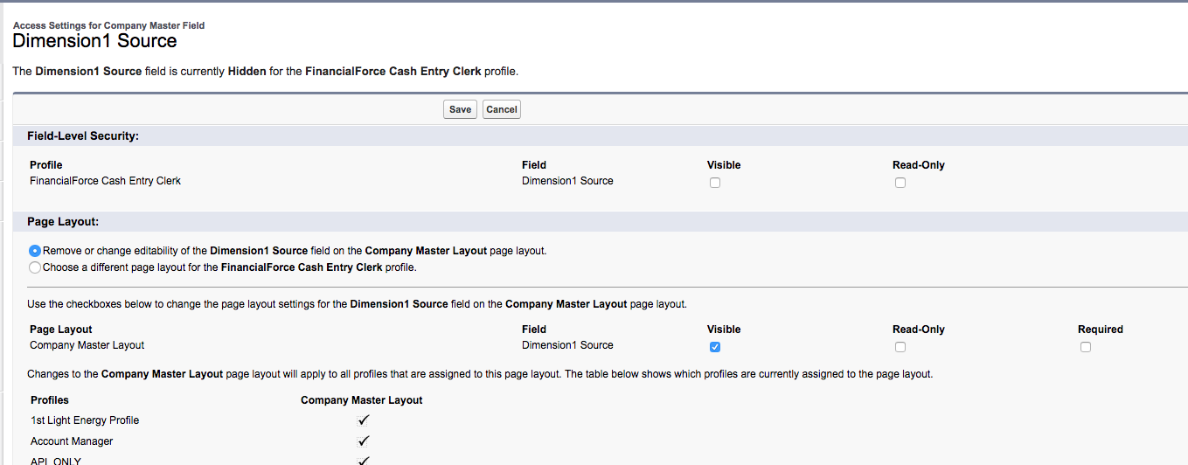

**Visualforce Page Access**

**By default we give all Rootstock profiles page access to all the pages as shown. Traverse to the desired profile and through quick links as shown go to Enabled VF page access section and Click ‘EDIT’**

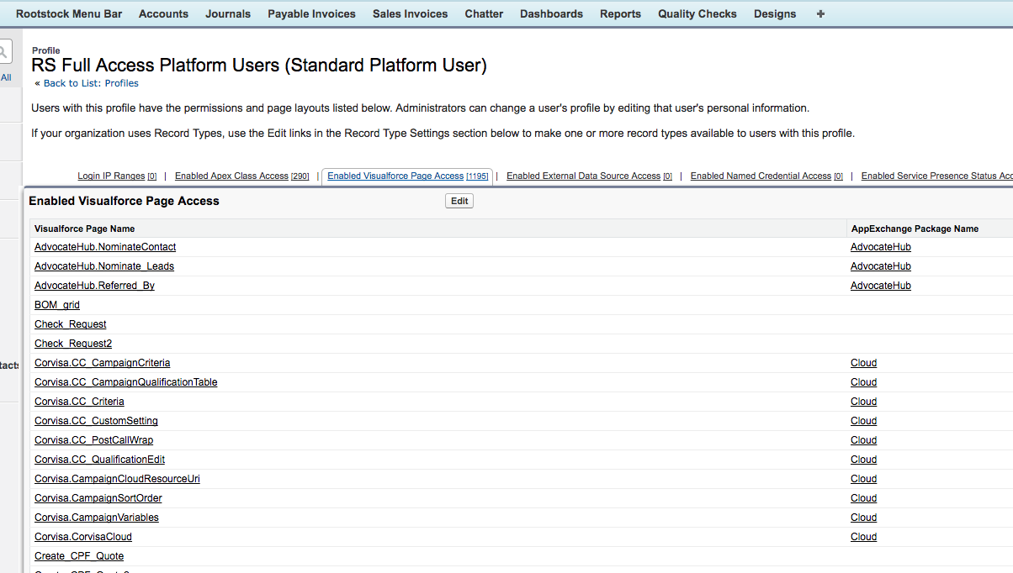

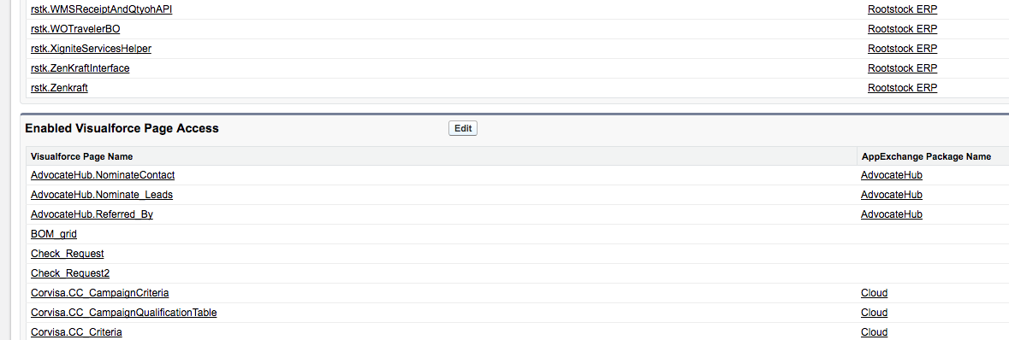

**Move the Rootstock profiles from the available to enabled list.**

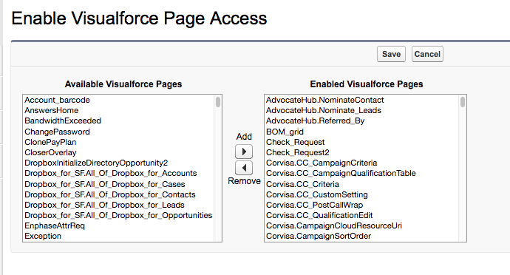

**To set permissions SPECIFICALLY for SOME Pages, follow the steps as shown.**

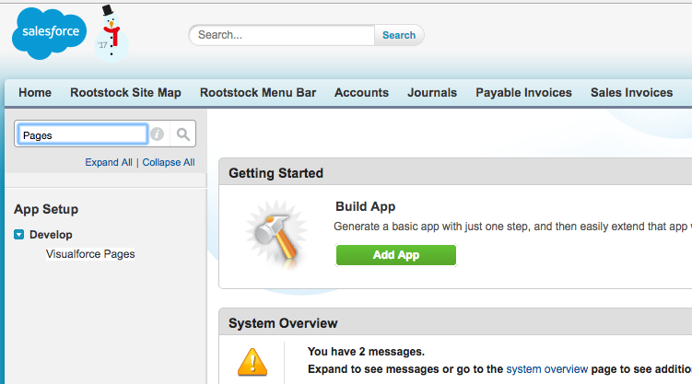

**CLICK ON ‘SECURITY’**

